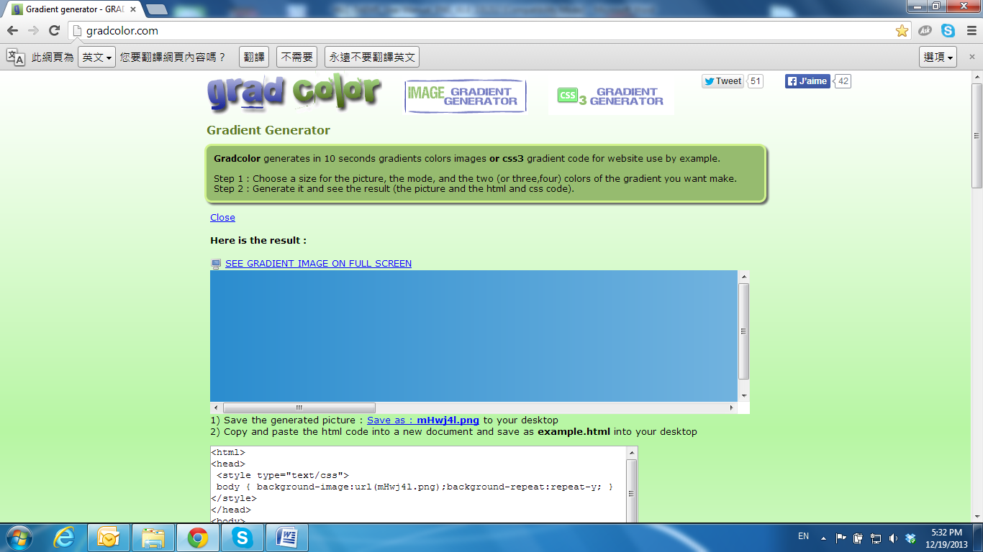

A / V Settings

Click 83-003 to get into the administration page. Click 83-007 to go back to the live video page.

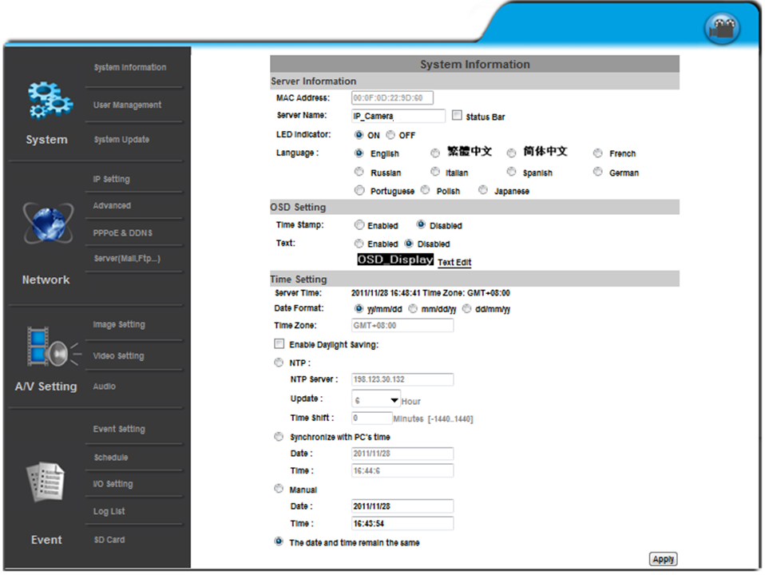

**1. Image Setting**

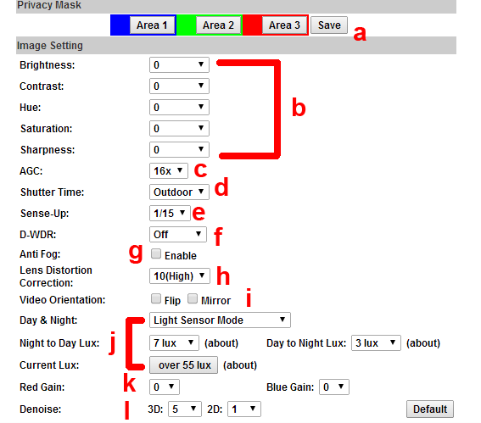Please refer to the details below for image settings:

a. For security and privacy purposes, there are three areas that can be set up for privacy. Click the **Area** button first, and then drag an area on the above image. Remember to save your settings. The masked area will not be shown on both live view and recording image.

b. Brightness, Contrast, Hue, Saturation, Sharpness can be adjusted here. The available values are: **-4, -3, -2, -1, 0, 1, 2, 3, 4**

c. AGC: The sensitivity of the camera can be adjusted to the environmental lighting. By enabling this function the camera will get brighter images on low light, but the level of noise may also increase. The available values are: **16x, 24x, 32x, 48x.**

d. Shutter Time: Choose the location of your camera or a fixed shutter time. The shorter the shutter time is the less light the camera receives and the image becomes darker.

|  |  |
| --- | --- |
| Option | Shutter Time Range (sec.) |
| Outdoor | 1/33000 ~ Selected number in **Sense-up** |
| Indoor | NTSC: 1/120 ~ Selected number in **Sense-up**  PAL: 1/100 ~ Selected number in **Sense-up** |
| 1/30 | 1/33000 ~ 1/30 |
| 1/50 | 1/33000 ~ 1/50 |
| 1/60 | 1/33000 ~ 1/60 |
| 1/100 | 1/33000 ~ 1/100 |
| 1/125 | 1/33000 ~ 1/125 |
| 1/250 | 1/33000 ~ 1/250 |
| 1/500 | 1/33000 ~ 1/500 |
| 1/1000 | 1/33000 ~ 1/1000 |
| 1/33000 | 1/33000 |
| **\* Sense-up options:** 1/30, 1/15, 1/10 | |

**Note:** When you select a number in **Shutter Time**, the shutter time will vary in a range and be controlled by camera automatically. The following table shows the shutter time options and corresponding range.

e. Sense up: When enabled, provides a higher sensitivity in low light conditions by slowing the shutter speed. The available values are: **1/30**, **1/15**, **1/10**, **1/5**.

f. D-WDR: This function enables the camera to reduce the contrast in the view to avoid dark zones as a result of over and under exposure. If the Input resolution is 30fps, the default value is fixed on **ENABLED**. The available values are: **OFF, 1, 2, 3, 4, 5, 6, 7, 8**

If the D-WDR is enabled the values for bright, dark and contrast can be adjusted.

g. Anti Fog: Improve the image clarity on environments presenting high levels of fog or smoke.

h. Lens Distortion Correction: Straight the curves in the borders of the image caused by the lens angles. The available values are: **OFF, 1, 2, 3, 4, 5, 6, 7, 8, 9, 10.**

i. Video Orientation: Flip or mirror the image.

j. Day & Night: The camera can detect the light level of the environment. If you choose **Light Sensor Mode**, the image will be turned black and white at night in order to keep a clear image. To set light sensor mode, appoint a Lux standard of switching D/N.

The current Lux value is provided for reference. Under **Times Mode** the switch time of Color / Black and white will be according to the given time.

You can also control it by choosing **Color** or **B/W**.

k. Red / Blue gain: Set the values for Red / Blue gain. The available values are: **-5, -4, -3, -2, -1, 0, 1, 2, 3, 4, 5**

l. Denoise: This function is able to filter the noise and blur from the image and show a clearer view. You can set the values for 2D and 3D filters.

**2. Video Setting**

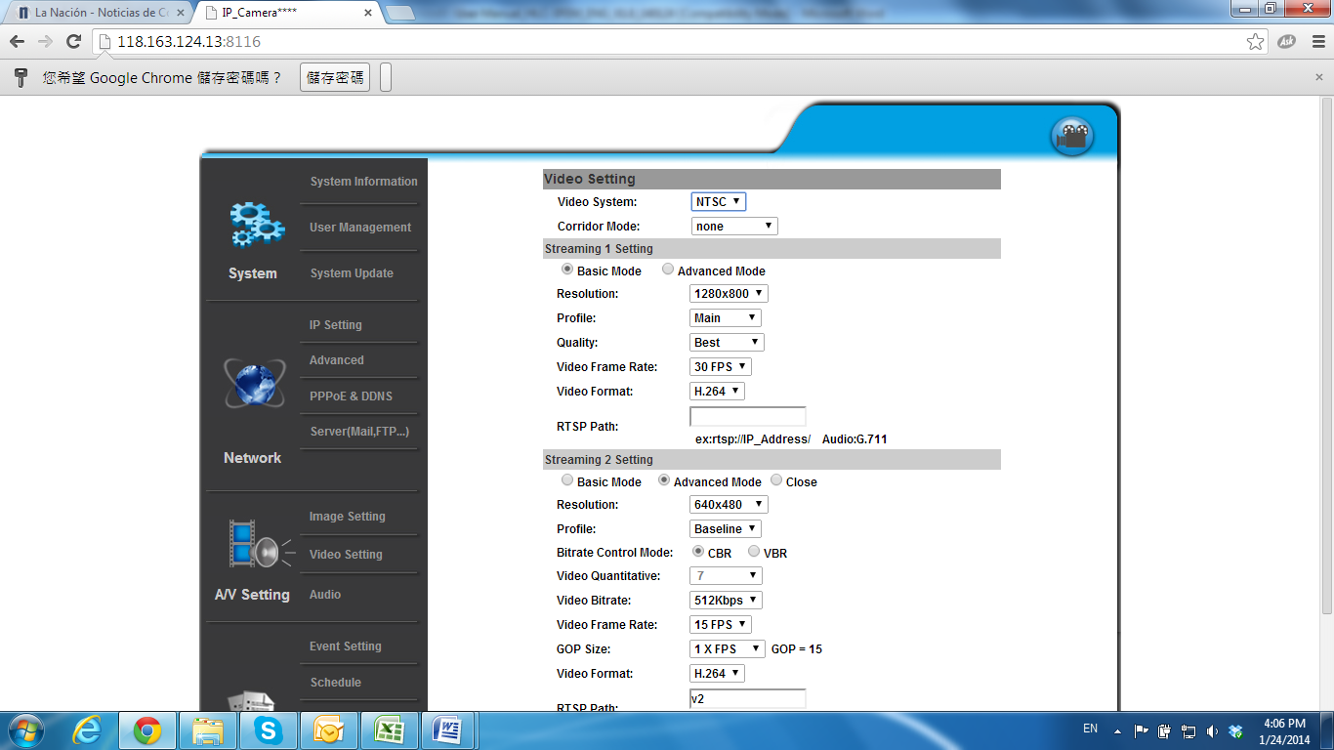

Video System: NTSC or PAL

Corridor Mode: 90 degrees, 270 degrees

On Corridor Mode please take note of the lens’ position. If **Corridor Mode** is set as **none** the relation of the image and the camera would be as the following:

Corridor mode: None

|  |  |
| --- | --- |
| **Image** | **Position** |
| 原影像 | zerodegrees.jpg  **0 degrees** |
| 用機器翻轉(1) | 90degrees拷貝.png  **90 degrees** |
| 用機器翻轉(2) | 270degrees拷貝.png  **270 degrees** |

Pictures based on other camera model

If Corridor Mode is set as **90 degrees** or **270 degrees** the relation of the image and the camera would be as the following:

Corridor Mode: 90 or 270 degrees

|  |  |
| --- | --- |
| **Image** | **Position** |
| 翻轉90度 | 90degrees拷貝.png  **90 degrees**  270degrees拷貝.png  **270 degrees** |
| 用機器翻轉(1) | zerodegrees.jpg  **0 degrees** |
| 用機器翻轉(2) | zerodegrees.jpg  **0 degrees** |

Pictures based on other camera model

1. Streaming 1 & 2 Basic Mode:

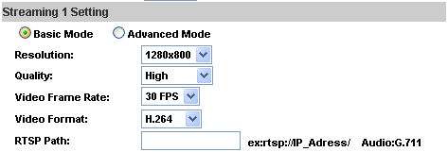

1. Resolution:

1920x1080@30fps, 1280x720@30fps, 640x480@30fps, 320x240@30fps, 176x144@30fps

1. Profile

Chose between Main or Baseline

1. Quality

There are 5 levels:

**Best/ High/ Standard/ Medium/ Low**

The higher the quality is, the bigger the file size is. Not good for internet transmission.

1. Video Frame Rate **(5~30 FPS):** The video refreshing rate per second.
2. Video Format: **H.264** or **JPEG**
3. RTSP Path: RTSP output name
4. Streaming 1 & 2 Advanced Mode:

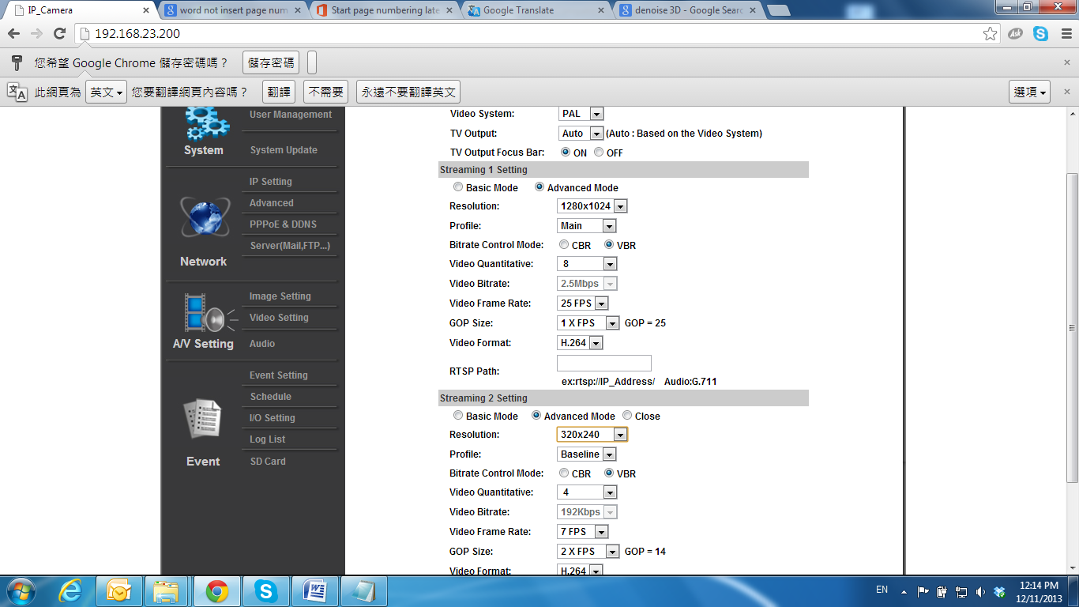

1. Resolution

1920x1080@30fps, 1280x720@30fps, 640x480@30fps, 320x240@30fps, 176x144@30fps

1. Profile

Chose between Main or Baseline

1. Bitrate Control Mode

There are CBR (Constant Bit Rate) and VBR (Variable Bit Rate)

CBR: **32Kbps~8Mbps** (the higher the CBR is, the better the video quality is)

VBR: **1(Low) ~10(High)** – Compression rate, the higher the compression rate, the lower the picture quality is; vise versa. The balance between VBR and network bandwidth will affect the picture quality. Select the VBR rate to avoid picture breaking up or lagging.

1. Video Frame Rate **(5~30 FPS)**: The video refreshing rate per second.
2. GOP Size **(1, 1/2, 2) X FPS**: "Group of Pictures". The higher the GOP is, the better the quality is.
3. Video Format: **H.264** or **JPEG**
4. RTSP Path: RTSP output connecting path
5. 3GPP Streaming mode:

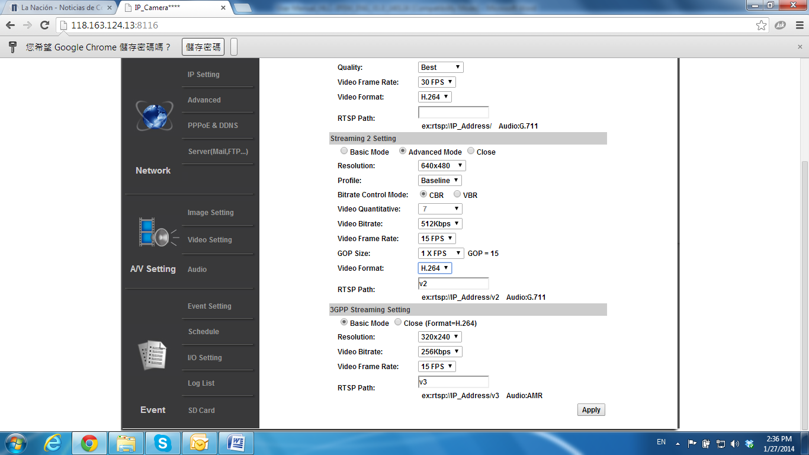

1. Resolution:

640x480@15fps, 320x240@15fps, 176x144@15fps

1. Video Bitrate:

**32Kbps~1Mbps** (the higher the Video Bitrate is, the better the video quality is)

1. Video Frame Rate

The video refreshing rate per second.

1. RTSP Path: RTSP output name

**3. Audio**

The IP Camera supports 2-way audio. The user can send audio from the IP Camera built-in microphone to the remote PC; the user can also send audio from remote PC to IP Camera’s external speaker.

1. Audio from IP camera built-in microphone to local PC: select **Enable** to start this function and select the audio type.

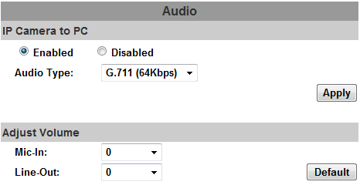

1. Audio from local PC to IP Camera: Check **chatting** in the browsing page.

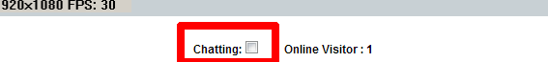

The Audio will not be smooth when the SD card is recording.

## 